Minutes of the 1st meeting of for revising the format of the synopses and theses held on
Tuesday, January 09, 2024, at Vice Chancellor’s Committee Room, Administration Block, Main Campus Charbagh, University of Swat

Meeting for revising the format of the synopses and theses was held on Tuesday, January 09, 2024, at Vice Chancellor’s Committee Room, Administration Block, Main Campus Charbagh, University of Swat.

Following attended the meeting:
Prof. Dr. Fazal Mabood
Dean, Faculty of Management and Social Sciences, University of Swat
Prof. Dr. Hazrat Bilal
Director, Center for Management and Commerce, University of Swat
Dr. Muhammad Mushtaq Ahmad
Associate Professor, Department of Arabic and Islamic Studies, University of Swat
Dr. Sana Ullah
Chairman, Department of Computer and Software Technology, University of Swat
Dr. Ghous Ur Rahman
Chairman, Department of Mathematics & Statistics, University of Swat
Dr. Haidar Ali
Director, Advanced Studies & Research, University of Swat

Meeting started with recitation from the Holy Quran. After recitation, the Chair welcomed all members and thanked them for sparing time for the meeting. Agenda item was thoroughly discussed.

Agenda Item

Revising the format of the synopses and theses in line with subject specific requirements of all the faculties, Departments, Centers, Institutes.
Recommendations:
The committee thoroughly discussed and recommended approval of the following format of synopses and theses of MS/M.Phil. and Ph.D.

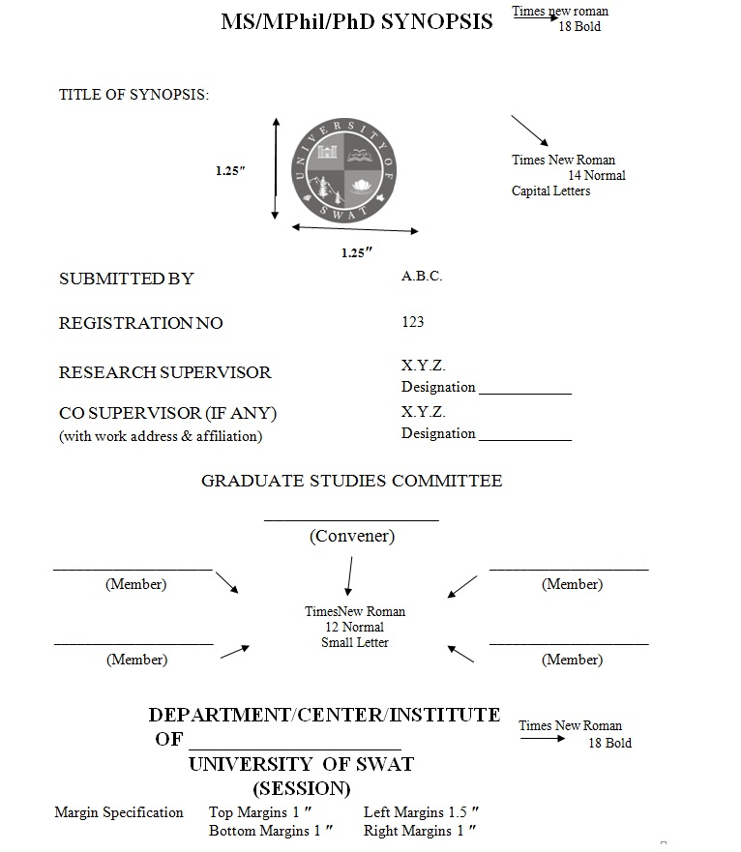
Title Page
Synopsis should be headed by a concise, specific, and informative title. It must be grammatically correct and should convey to the reader the nature of the work to be carried out. The title should be in capital words (Times New Roman 14 Normal). The title must be followed by the University Monogram (Dimension Horizontal 1.25; Vertical 1.25) followed by research scholar name (Times New 12 Normal Capital Words), Supervisor name, Co-Supervisor name (if any) Times New Roman 12 capital words - along with work address and affiliations (in case of Co-Supervisor) in case of supervisor no need to mention work address and affiliations, followed by Graduate Studies Committee (Times New Roman 12 Normal capital letters,) Signature columns for Convener, and members of Graduate Studies Committee (Times New Roman 12 Normal small letters), followed by address of Department/Institute/Centre where the scholar is enrolled along with the Session (Times New Roman 18 bold).

Margins are detailed as under
Top Margin: 1.0 inch
Bottom margin: 1.0 inch
Left Margin: 1.5 inch
Right Margin: 1.0 inch

Page 1: Text Layout
The title must be written on the first line below the page header.
All material must be typed (12-point font, Times New Roman) and 1.5-spaced on A-4 size paper.
The text should be provided under headings, namely: Introduction, Problem Statement/Research Question/Hypothesis (whichever applicable), Objectives, Methodology or Plan of Work (whichever applicable), Significance and References. Headings and sub-headings for different sections should be clearly indicated. Abbreviations used in the text, and must be clearly defined in full on the first use. Synopsis should be properly paginated (in the upper right-head corner of each page).

Introduction (Times New Roman 12 bold)
Essential background information may be provided to introduce the proposed research, supported by adequate and updated references (including 05 from the last three years). Research proposal should carry a highly structured literature review along with the gap analysis which can be covered through this research proposal. It should briefly discuss the broader context within which the research is planned. It is in fact the justification of the proposed research work, by encompassing the research problem and identification of research gap. The introduction should be based on a thorough analysis of relevant literature, critically examining the existing resources to pinpoint an objective that, once achieved, will make a substantial contribution to the field. This proposed research endeavor upon completion will introduce novel insights, enhance existing knowledge, or devise an innovative methodology that will offer significant advantages compared to those already established in the field.

Problem Statement/Research Question/Hypothesis (whichever applicable)
(Times New Roman 12 bold)

Objectives (Times New Roman 12 bold)
The scholar will list down the main objectives of the study. When objectives are more than one, they should be numbered in Roman Numerals, i.e. i, ii, iii, and so on.

Methodology or Plan of Work (which ever applicable) (Times New Roman 12 bold)
This part of synopsis should contain how a scholar will conduct the experimental work/survey/interviews etc. which type of instrument will be used and under which condition the research would be carried out. How the scholar will be optimized various conditions and problems encountered during the study would be addressed.
Further subtopics may be added if the scholar wants.

Significance (Time New Roman 12 bold)
The scholar will explain the significance of its expected outcome. The scholar will provide
- the justification, importance, and vital contribution of the findings of the study / research and its likely benefits.
- Why is it worth doing?
- While the particular topic and its context will determine a study’s significance and contribution of a study in terms of: adding to the existing knowledge in the area; policy considerations; implications for practitioners etc.

References (Times New Roman 12 bold)
- One style of the references i.e. APA or Turabian should be followed, that shall be decided by the Department to select any of the aforementioned styles.
- The Chicago and Nastaleeq style is allowed for IRS and Urdu Department if applicable] but the size of heading/subheading and other parameters must be followed. The Departmental Committee must ensure that the scholars have followed the approved style.
- Arrange references in a list under the heading “References “at the end of the synopsis. They should not be treated as footnotes.
- Do not leave blank lines between references.
- Verify the accuracy of all reference before citation.
- Unnecessarily a long list of references should be avoided.

Examples for references citation
References: References must be arranged alphabetically and stick to the format.
  - In the text, in case of one author should be cited as (e.g. Stephens, 2018).
  - In case of two authors in parenthesis, both authors must be separated with "&" and not with full "and" (e.g. Brown & Endrizzi, 2016).
  - In case of publications of more than two authors, the name of first author should be followed by et al., (e.g. Zhang et al., 2017).
  - In case of two or more citations in the text, the citation must be arranged in chronological order (Stephens, 2009; Brown & Endrizzi, 2010; Ashraf et al., 2012, Wang, 2014; Sajid & Aqeel; 2018).
  - The titles of journals should be abbreviated according to the Thomson Reuters Journal List (Journals in the 2016 Release of Journals). In case of more than one publication by the same author in the same year, the references must be separated by a, b, c etc. (e.g. Ashraf et al., 2004a, 2004b; Wang & Liu, 2018).

Examples:
Journal article
Milborrow, B.V. (2001). The pathway of biosynthesis of abscisic acid in vascular plants: a review of the present state of knowledge of ABA biosynthesis. J. Exp. Bot., 52, 1145-1164.
Chen, K. & R. Arora. (2011). Dynamics of the antioxidant system during seed Osmo priming, post-priming germination, and seedling establishment in Spinach (Spinacia oleracea). Plant. Sci., 180(2), 212-220.
Sana, F., F. Ahmad, M. Hameed & R. Ahmad. (2018). Ecology and species association of grass species in response to altitudinal gradient in the Potohar region. Pak. J. Bot., 50(1), 41- 49.
Cheng, G., Y. Jiang, Y. Chen, S. Yang, S. He, H. Liang & X. Duan. (2011). Combined effects of pectic enzymes on the degradation of pectin polysaccharides of banana fruit. Pak. J. Bot., 43(3), 1501-1505.

Book
Corner, E.J.H. (1976). The Seeds of Dicotyledons. Vol: 1. Cambridge University Press, Britain, pp. 1-123.

Book Chapter
Alam, S.M. (1994). Nutrients by plants under stress conditions. In: Pessrakli, M. (Ed.), Handbook of Plant and Crop Stress. Marcel Dekker, New York, pp. 227-246.
Ashraf, M.Y. & G. Sarwar. (2002). Salt tolerance potential in source members of Brassicaceae: Physiological studies on water relations and minerals contents. In: Ahmad, R. & K.A. Malik (Eds.) Prospects for Saline Agriculture. Kluwer Academic Publishers, The Netherlands, pp. 237-245.

Edited Book
Ali, S.I. & M. Qaiser (Eds.). (2001). Flora of Pakistan. 205. University of Karachi, Karachi.

